Name _______________________________ Date___________

The students described below need your help.
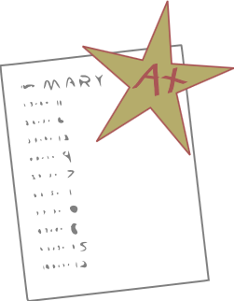
- James said the factors of the expression: 5 · (8 – a) are 5, 8 and a. Do you agree or disagree? Explain.

- Jimmy had to list the coefficients for each term in the following expression: ${15x}^{2 }$– x – 8
His answer was “15.” Did he get it right? Explain.

- Jennifer was asked to rewrite each of the following expressions in word form, using the words sum, product, difference, and quotient as needed. Write the answer she should give.

- (y - 3)20

- 5 + $\frac{x}{9}$

