6.EE.2C - Evaluate Expressions Think, Pair, Share Name_____________________
My Answer  Evaluate the expression in the space below. | My Partner’s Answer  Record your partner’s answer in the space below | Our Final Answer  Talk with your partner and decide who is correct if your answers are different. Listen to their reasoning as you examine their work.
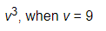
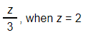
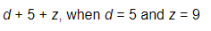

Find more resources at https://goalbookapp.com

