6.EE.1 Write and evaluate numerical expressions involving whole-number exponents.

Students read algebraic expressions:
- r + 21 as “some number plus 21” as well as “r plus 21”
- n · 6 as “some number times 6” as well as “n times 6”
- $\frac{s}{6}$and s ÷ 6 as “as some number divided by 6” as well as “s divided by 6”
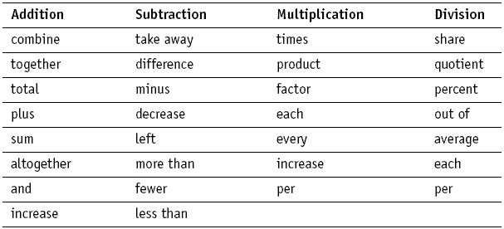
6.EE.2a Write expressions that record operations with numbers and with letters standing for numbers

Students write algebraic expressions:
- 7 less than 3 times a number is 3x – 7
- 3 times the sum of a number and 5 is 3 (x + 5)
- 7 less than the product of 2 and a number is 2x – 7
- Twice the difference between a number and 5 is 2(z – 5)
- The quotient of the sum of x plus 4 and 2 is $\frac{x+4}{2}$
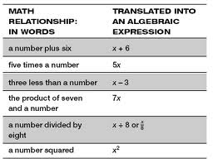
Student Notes:

6.EE.2b Identify parts of an expression using mathematical terms (sum, term, product, factor, quotient, coefficient); view one or more parts of an expression as a single entity.

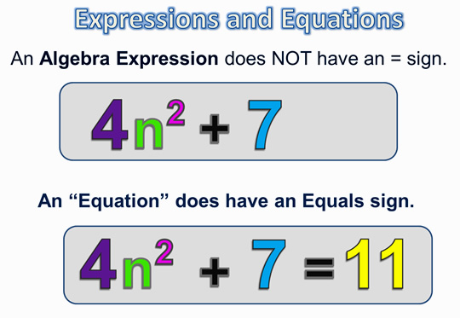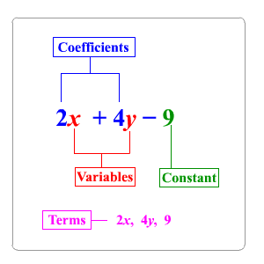
6.EE.2c Evaluate expressions at specific values of their variables. Include expressions that arise from formulas used in real-world problems. Perform arithmetic operations, including those involving whole- number exponents, in the conventional order when there are no parentheses to specify a particular order (Order of Operations).

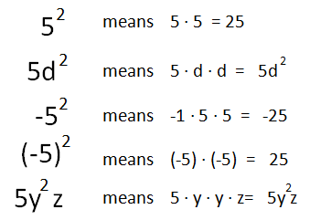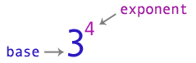

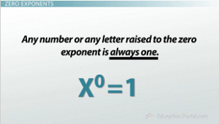
Student Notes:

Order of operations is introduced throughout elementary grades, including the use of grouping symbols, ( ), { }, and [ ] in 5th grade. Order of operations with exponents is the focus in 6th grade.
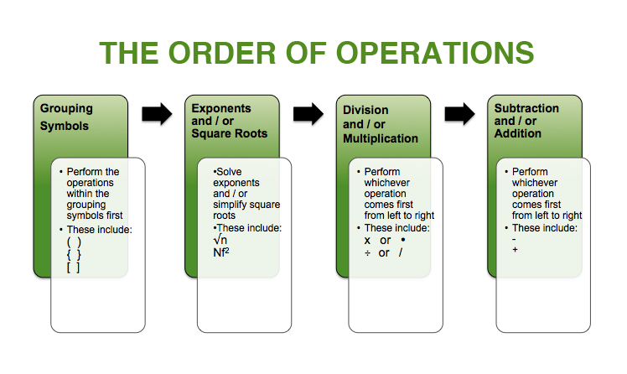
Example 1:
Evaluate the expression 3x + 2y when x is equal to 4 and y is equal to 2.4.
Solution:
3 • 4 + 2 • 2.4
12 + 4.8
16.8

Example 2:
Evaluate 5(n + 3) – 7n, when n = $\frac{1}{2}$.
Solution:
5( $\frac{1}{2}$+ 3) – 7($\frac{1}{2}$)
5 (3$\frac{1}{2}$) - 3$\frac{1}{2}$
17$\frac{1}{2}$ - 3$\frac{1}{2}$
14
Student Notes:

Example 3:
Evaluate 7xy when x = 2.5 and y = 9
Solution: Students recognize that two or more terms written together indicates multiplication.
7 (2.5) (9)
157.5
Example 4:
Evaluate the following expression when x = 4 and y = 2
x² + y³
3
Solution:
4² + 2³
3
16 + 8
3
24 = 8
3

Example 5:
It costs $100 to rent the skating rink plus $5 per person. Write an expression to find the cost for any number (n) of people. What is the cost for 25 people?
Solution:
The cost for any number (n) of people could be found by the expression, 100 + 5n. To find the cost of 25 people substitute 25 in for n and solve to get 100 + 5 * 25 = 225.

Student Notes:

6.EE.3 Apply the properties of operations to generate equivalent expressions. For example, apply the distributive property to the expression 3 (2 + x) to produce the equivalent expression 6 + 3x; apply the distributive property to the expression 24x + 18y to produce the equivalent expression 6 (4x + 3y); apply properties of operations to y + y + y to produce the equivalent expression 3y.

Example 1:
Given that the width is 4.5 units and the length can be represented by x + 3, the area of the flowers below can be expressed as 4.5(x + 3) or 4.5x + 13.5.
x 3
iris
roses
4.5

Example 2:
The expression 10x + 15 can represent the area of the figure below. Students find the greatest common factor (5) to represent the width and then use the distributive property to find the length (2x + 3). The factors (dimensions) of this figure would be 5(2x + 3).
15
10x

Example 3:
Students use their understanding of multiplication to interpret 3 (2 + x) as 3 groups of (2 + x). They use a model to represent x, and make an array to show the meaning of 3(2 + x). They can explain why it makes sense that 3(2 + x) is equal to 6 + 3x. An array with 3 columns and x + 2 in each column:

Student Notes:

In 6th grade students are able to use the properties and identify by name as used when justifying solution methods.

Example 4:
Prove that y + y + y = 3y
Solution:
y + y + y
y • 1 + y • 1 + y • 1 Multiplicative Identity
y • (1 + 1 + 1) Distributive Property
y • 3
3y Commutative Property

Example 5:
Write an equivalent expression for 3(x + 4) + 2(x + 2)
Solution:
3(x + 4) + 2(x + 2)
3x + 12 + 2x + 4 Distributive Property
5x + 16
6.EE.4 Identify when two expressions are equivalent (i.e., when the two expressions name the same number regardless of which value is substituted into them). For example, the expressions y + y + y and 3y are equivalent because they name the same number regardless of which number y stands for.

Example 1:
Are the expressions equivalent? Explain your answer?
4m + 8 4(m+2) 3m + 8 + m 2 + 2m + m + 6 + m
Student Notes:

