6.NS.2 Fluently divide multi-digit numbers using the standard algorithm.

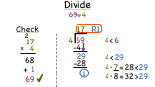

6.NS.3 Fluently add, subtract, multiply, and divide multi-digit decimals using the standard algorithm for each operation.

Add/Subtract Decimals
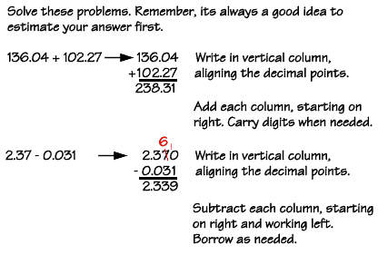

Student Work:

Multiply Decimals
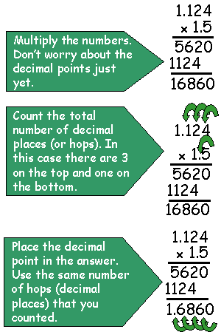

Divide Decimals
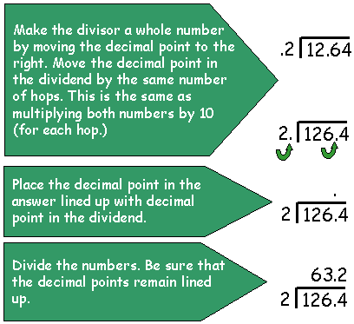

Student Notes:

6.NS.4 Find the greatest common factor of two whole numbers less than or equal to 100 and the least common multiple of two whole numbers less than or equal to 12. Use the distributive property to express a sum of two whole numbers 1–100 with a common factor as a multiple of a sum of two whole numbers with no common factor. For example, express 36 + 8 as 4 (9 + 2).

Rules of Divisibility
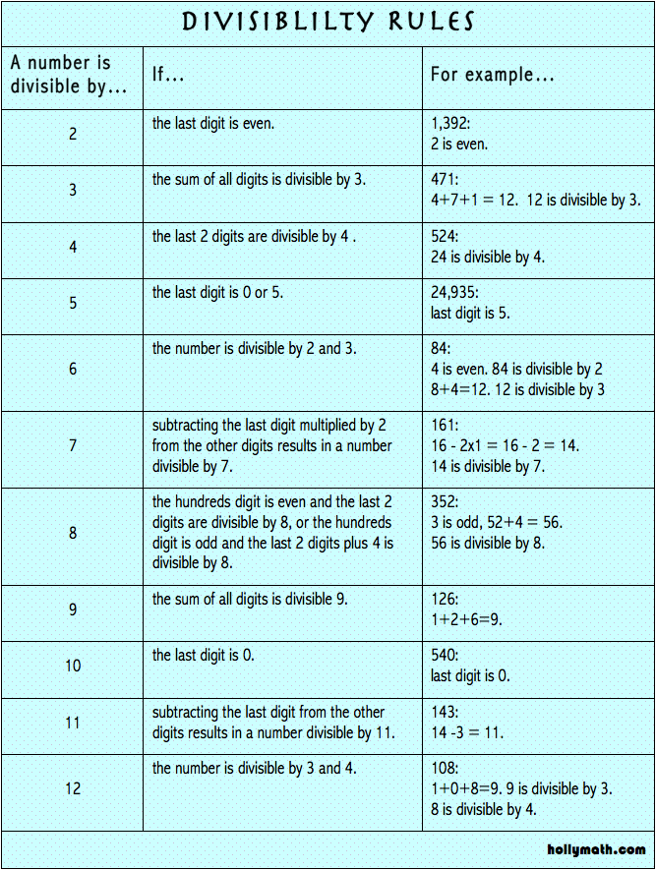

Student Notes:

Prime and Composite Numbers
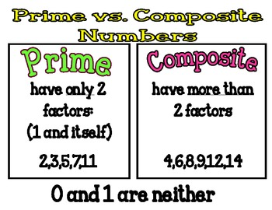

Prime Numbers from 1-100
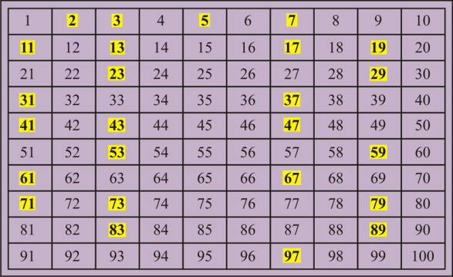

Student Notes:

GCF and LCM Using the Ladder Method
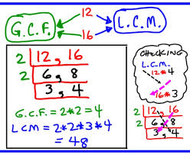

Real World Scenarios
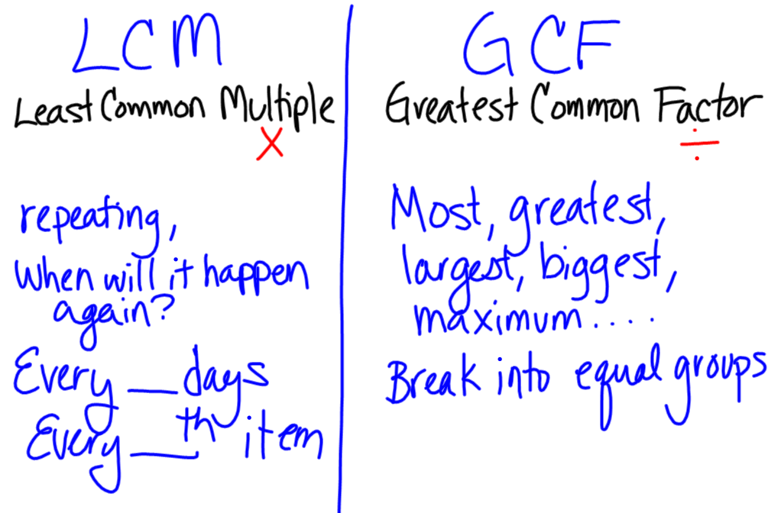

Fraction Applications for GCF and LCM?

Student Notes:

Distributive Property
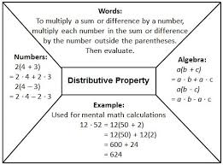

Distributive Property and Models
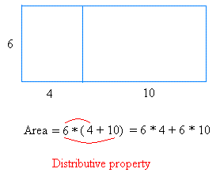

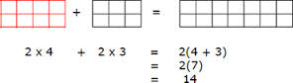

Student Notes:

Distributive Property and GCF
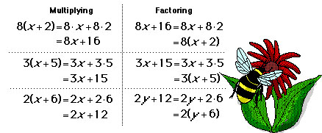

6.NS.1 Interpret and compute quotients of fractions, and solve word problems involving division of fractions by fractions, e.g., by using visual fraction models and equations to represent the problem.

Converting Improper Fractions to Mixed Numbers (Review)
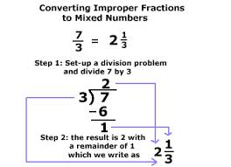
Converting Mixed Numbers to Improper Fractions (Review)
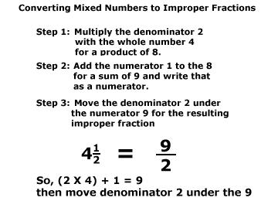
Student Notes:

Multiply Fractions with Models (Review)
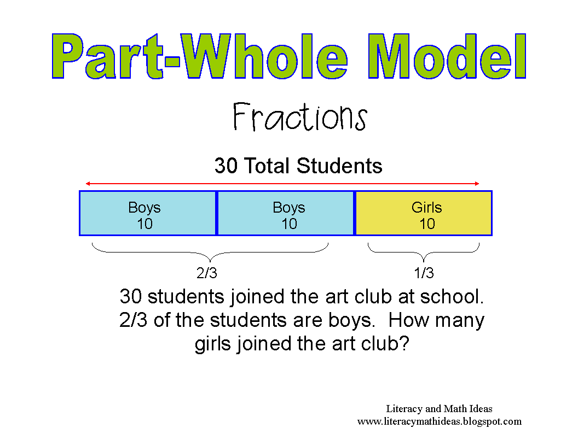
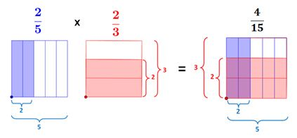
Divide Fractions with Models
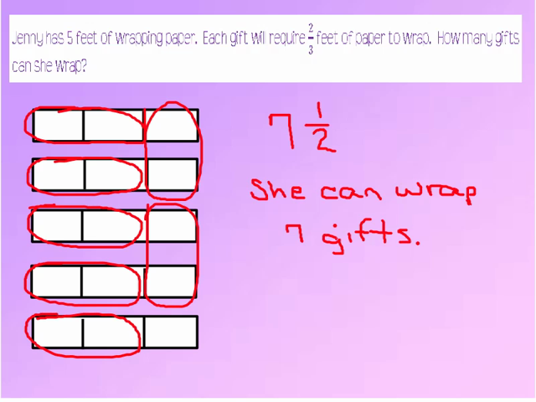
Divide Fractions with Algorithm
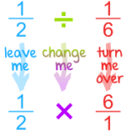
Student Notes:

